# Module 7 Day 1

## Lesson 1.1 User Interviews

### Understanding the Role of User Interviews

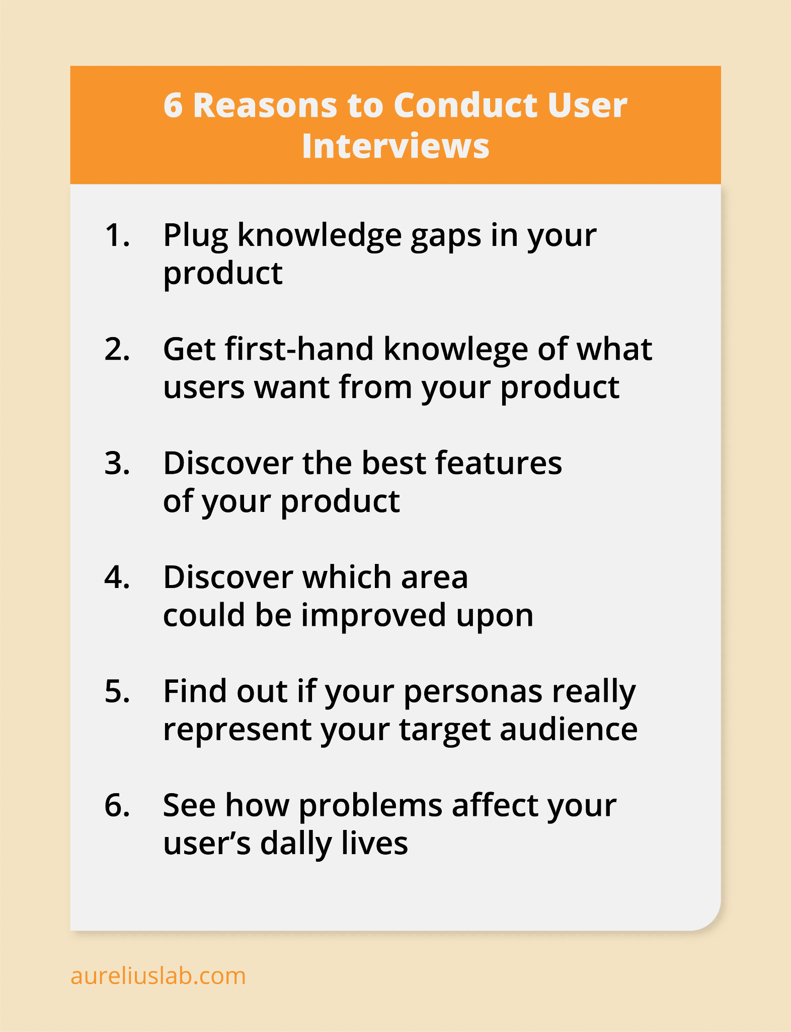

<https://www.aureliuslab.com/ux-user-research-interview-guide>

User interviews are one of the quintessential methods of gathering qualitative data directly from your target audience. Their significance lies in their ability to provide real insights from real users. When we create products, our vision and our users' expectations may not always align. That's where user interviews come into play.

* **What do user interviews help researchers and designers do?**
  + User interviews offer a direct line of communication with the user. They help researchers and designers:
    - Validate hypotheses.
    - Understand user pain points and needs.
    - Gain insights into user behavior, motivations, and preferences.
    - Ensure that the products are functional and user-centric.

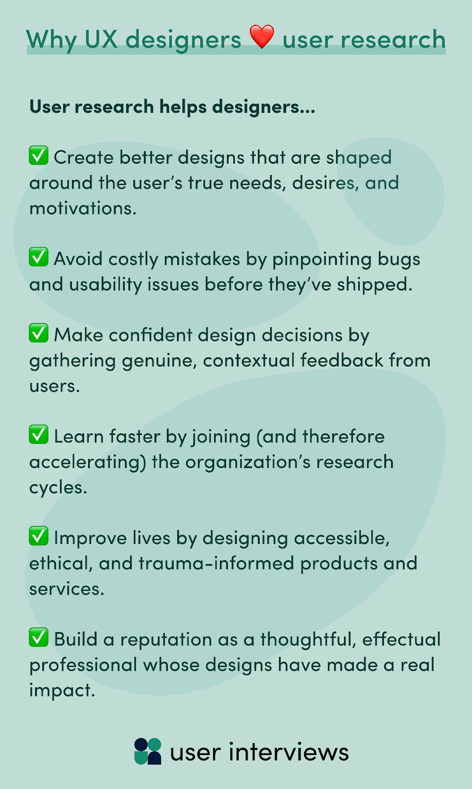

<https://www.userinterviews.com/blog/user-research-for-ux-designers>

### Defining User Interviews

At their core, user interviews are structured conversations where researchers seek to obtain information from users about a product, service, or concept.

* **What are user interviews used for?**
  + Identifying usability issues.
  + Understanding user goals and tasks.
  + Gaining feedback on new concepts or prototypes.
  + Gathering qualitative data to support design decisions.

### Zooming in on Qualitative User Research

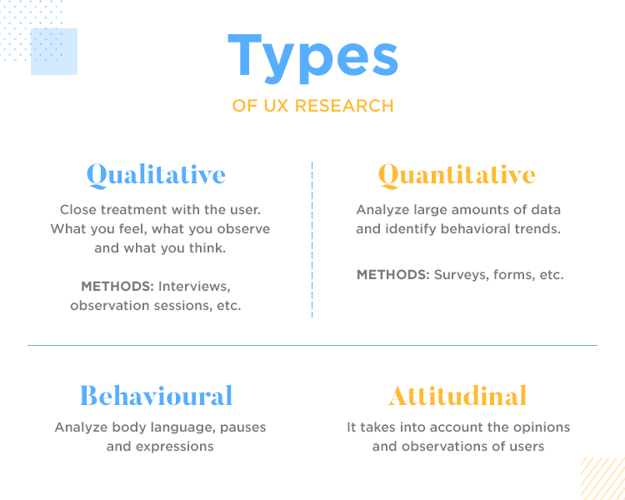

<https://www.justinmind.com/blog/ux-research/>

Qualitative research is exploratory and aims to understand underlying reasons, opinions, and motivations. It provides depth and detail.

* **What is qualitative user research?**
  + It seeks to understand 'why' and 'how' users behave a certain way, not just 'what', 'where', and 'when'.
  + It's more about narratives, emotions, and patterns than numbers and charts.
  + Often, it is based on observations, conversations, and analysis of user tasks.
* **Qualitative Focused User Interviews:**
  + These interviews lean heavily on open-ended questions to gather rich, detailed answers.
  + They prioritize understanding user emotions, motivations, and the context behind their actions.

### Diving Into the Types of User Interviews

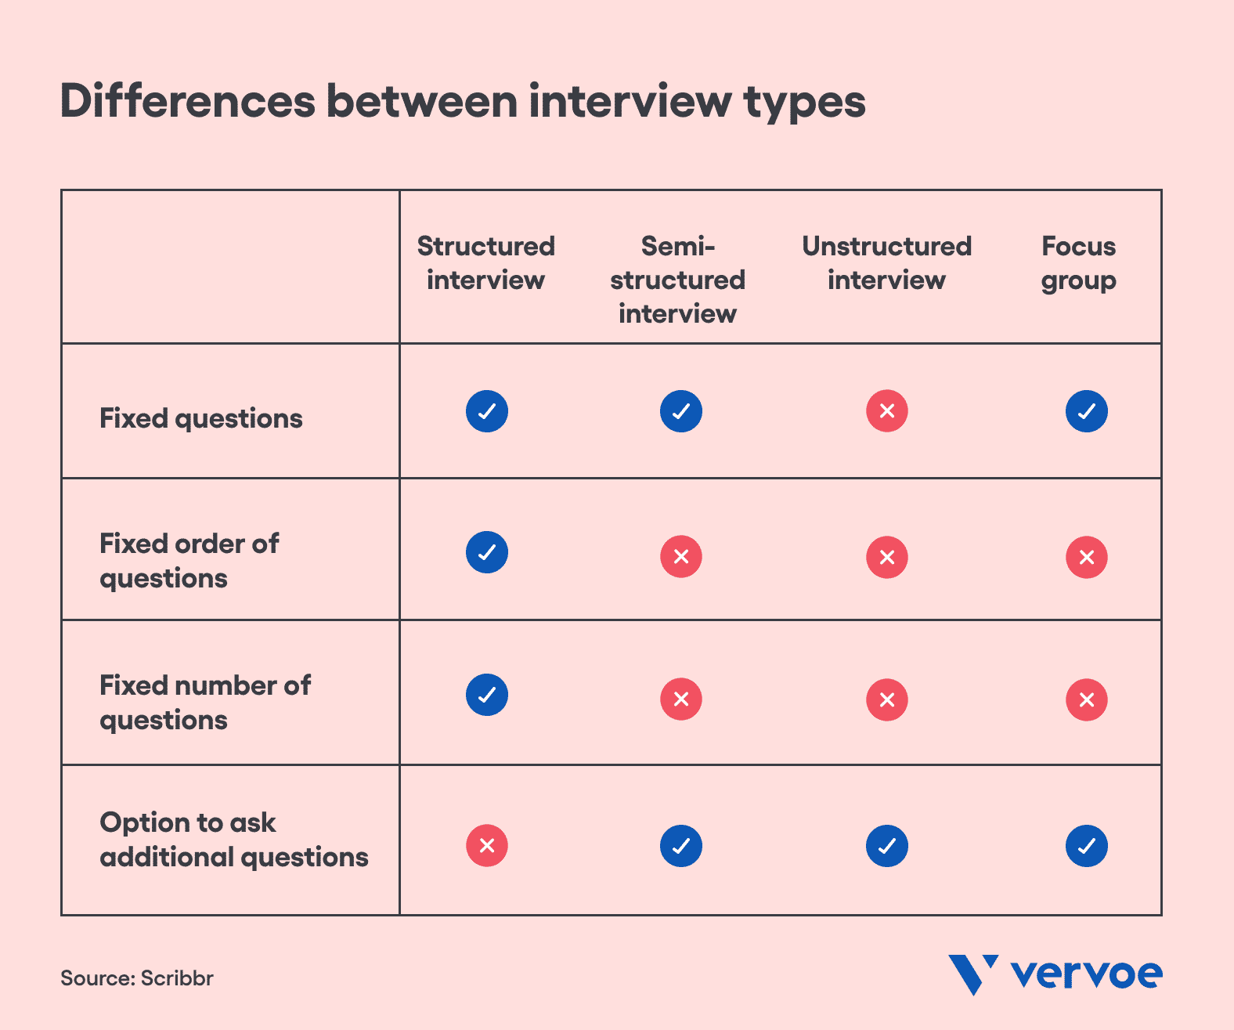

| Interview type | What it is | When to use it |
| --- | --- | --- |
| Structured interview | A predetermined list of questions asked in the same order to every candidate. | If you want to accurately compare candidates to assess who is most suitable. If you are short on time and resources and need a quick and accurate comparison. If you have a clearly defined candidate persona with specific characteristics. If you want to assess candidates objectively and fairly to reduce bias in your interview process. If you have knowledgeable interviewers (i.e., subject matter experts) who understand what a bad or good response looks like. |
| Semi-structured interview | A few questions are predetermined, and the remaining questions are determined by the direction of the conversation. | If you want to compare candidates side by side for certain questions, while also seeing where the conversation naturally goes. |
| Unstructured interview | None of the questions are predetermined. Instead, the interviewer engages in a free-flowing conversation and allows the direction to influence what questions are asked. This means candidates are likely asked different questions and can’t be compared side by side. | If you want more personal and informal interviews where candidates feel comfortable answering naturally and honestly. |

<https://vervoe.com/what-is-a-structured-interview/>

* **Structured Interviews:** These are strictly scripted. Every participant is asked the same set of questions in the same order, ensuring consistency.
* **Semi-structured Interviews:** A blend of structured and unstructured. While there is a script or a list of topics to cover, the interviewer can deviate, dig deeper, or explore new paths that arise during the conversation.
* **Unstructured Interviews:** No script. The conversation flows freely, guided by the interviewer's knowledge of the topic and the information the participant shares.

### The Ripple Effect: Impact of User Interviews

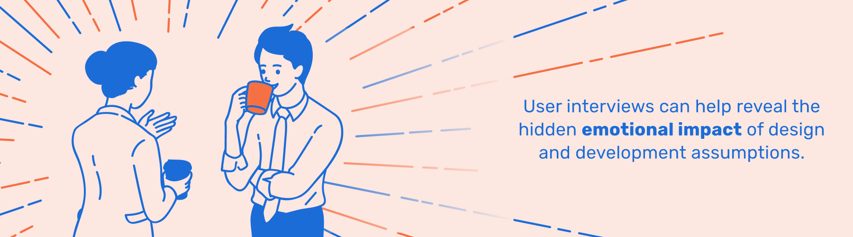<https://blog.pint.com/human-centered-web-design-begins-with-ux-research/>

User interviews can:

* Highlight unexpected ways users interact with a product.
* Provide insights that can lead to innovative features or solutions.
* Validate if a product or feature is on the right track.
* Influence stakeholder decisions by providing real user feedback.

### Timing is Everything: When to Conduct Interviews

Interviews can be conducted:

* The best time to conduct user interviews is throughout the entire design process.
* At the start of a project to identify user needs and set direction.
* During the design phase to validate decisions and iterate.
* After launch to gather feedback and identify areas for improvement.

### Mapping Out Success: Setting Goals and Planning

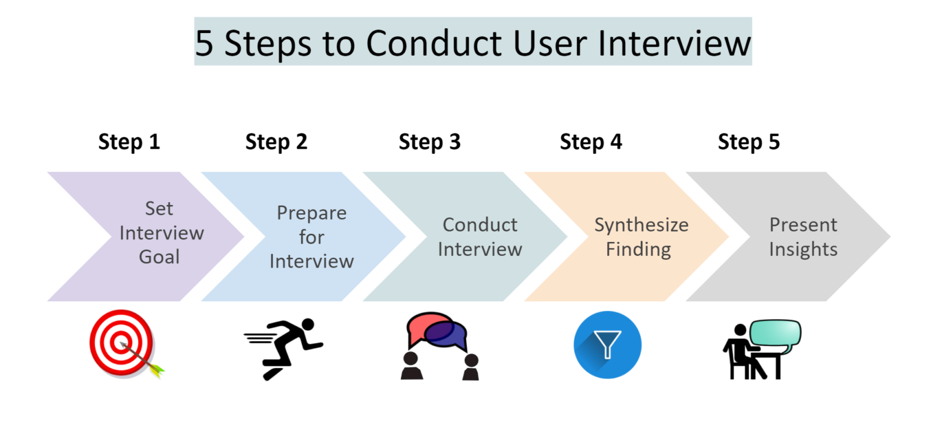

<https://www.linkedin.com/pulse/how-conduct-user-interviews-reetika-gupta/>

Embarking on user interviews without a plan is like setting sail without a compass.

* **Identifying Your Objectives:** Before you even begin, know what you want to achieve. Is it to validate a design? Understand user pain points? Identify opportunities for a new feature?
* **Recruiting Participants:**
  + Target your user demographic.
  + Ensure a diverse representation to capture a wide range of insights.
* **Crafting Your Questions:**
  + Use a mix of open-ended (e.g., "How do you feel about...?") and closed questions (e.g., "Do you use...?").
  + Avoid leading questions that may bias the participant.
  + Aim for clarity, and test your questions beforehand if possible.

## Lesson 1.2 Types of User Interviews

### Exploring Different Types of User Interviews

User interviews come in various forms, each with a specific purpose and method of approach. They are selected based on the nature of the data required and the stage of the project.

* **Contextual Interviews:**
  + These are conducted in the user's natural environment, whether it's at their home, workplace, or any other relevant setting.
  + Observing users in their own environment helps researchers gather insights about how the product fits into users' lives and routines.
  + It allows for understanding the physical, social, and technological context of use.
  + Used to learn from users through the design process. By observing them in context, designers can gain a deeper understanding of user behaviors, pain points, and needs.
* **Generative Interviews:**
  + Aimed at generating new ideas or concepts.
  + Used in the early stages of product development or redesign when the focus is on understanding the broader user needs and motivations.
  + Participants might be asked to dream up an ideal solution or express their deepest needs and challenges.
  + Used to generate ideas and requirements for a new product, service, or feature.
* **Continuous Interviews:**
  + Regular and ongoing interviews that happen at various stages of product development.
  + They ensure that the product team stays aligned with user needs and can adapt to any changes or new insights.
  + Used to continuously gather feedback and make iterative improvements. It ensures that the product remains aligned with user needs as they evolve over time.

### Diving into Question Types: Open vs. Closed Questions

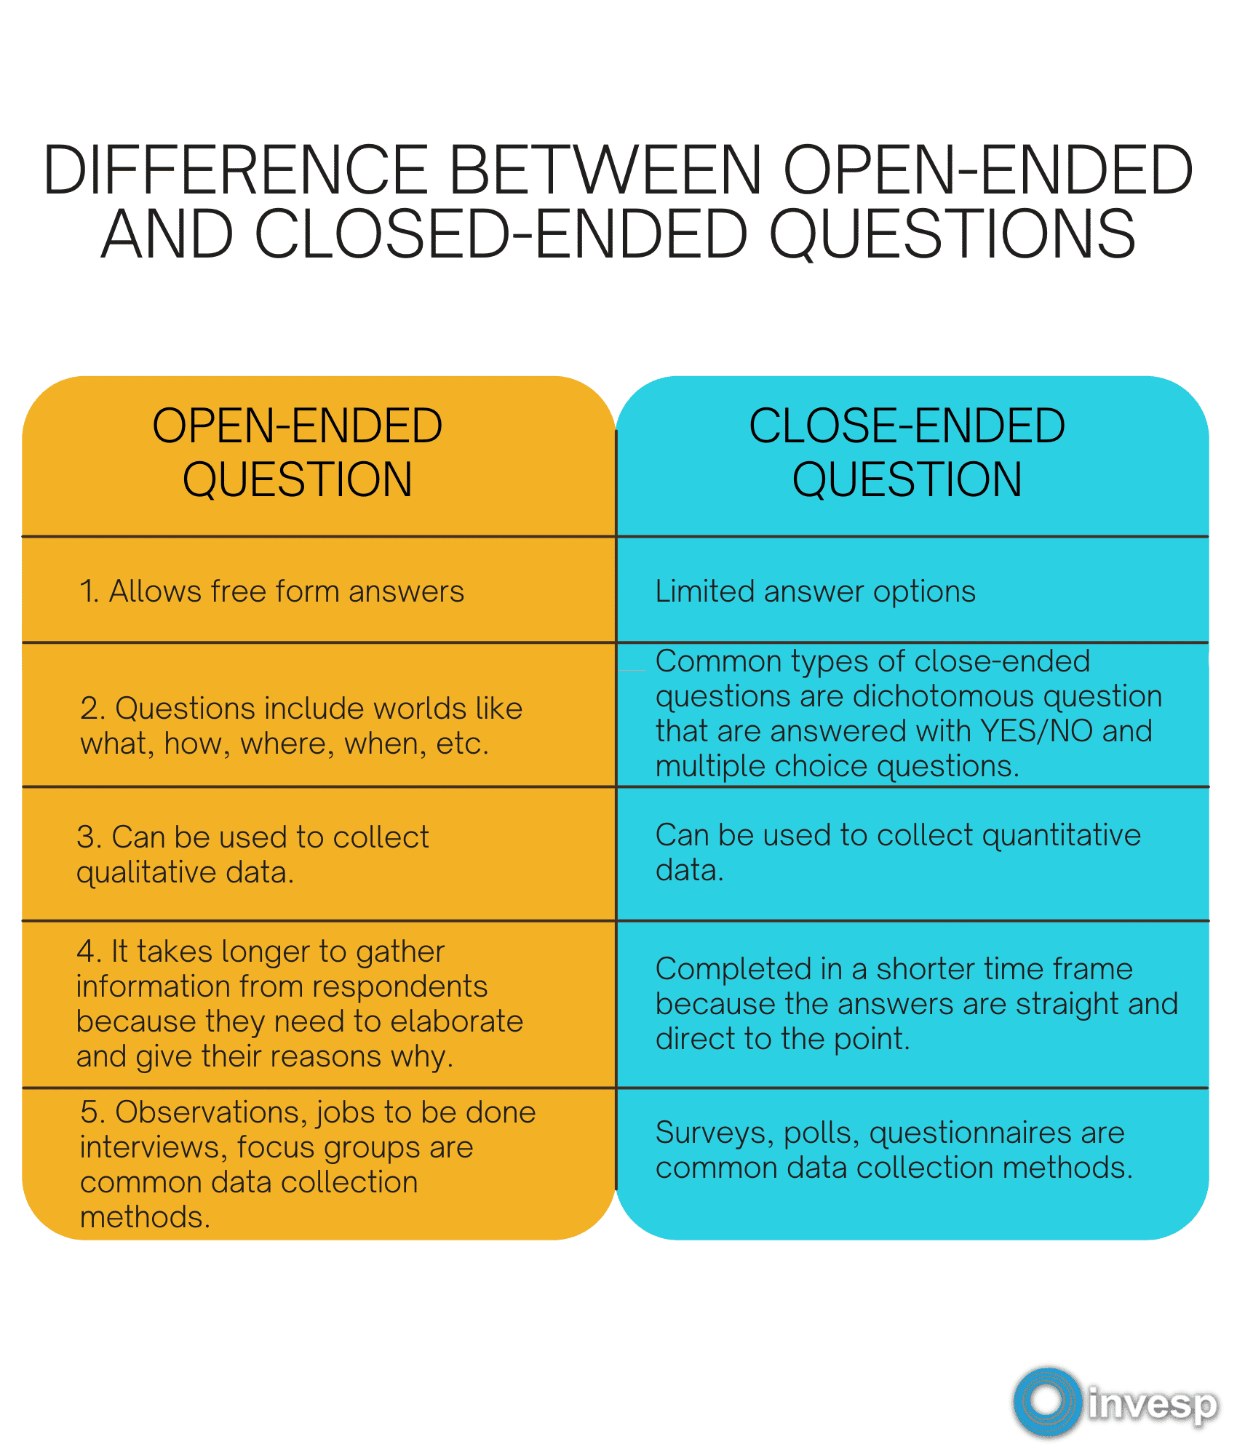<https://www.invespcro.com/blog/open-ended-questions-and-closed-ended-questions-what-they-are-and-how-they-affect-user-research/>

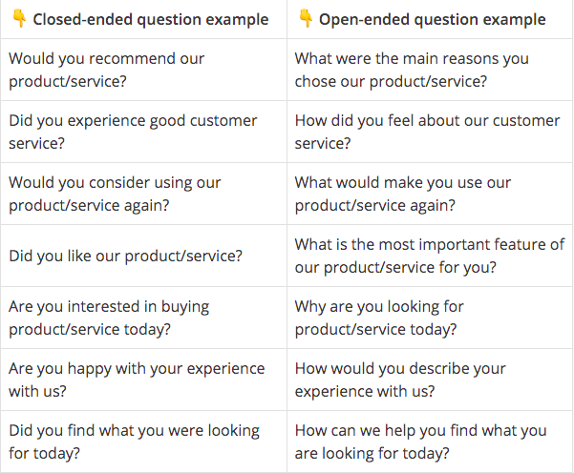

* **Open Questions:**
  + Encourage a broad and detailed response.
  + E.g., "How do you feel about the current layout of the app?"
  + Advantages: Gain deeper insights, understand emotions and motivations.
* **Closed Questions:**
  + Yield specific and often short answers.
  + E.g., "Have you used this feature before?"
  + Advantages: Can be quicker to answer, easier to analyze, and helps in quantifying certain aspects.

### Sample Interview Questions

1. *For Contextual Interviews:*
   * "Can you show me how you typically use this product during your day?"
   * "What other tools or products do you use alongside this one?"
2. *For Generative Interviews:*
   * "What challenges do you face when trying to achieve [specific task]?"
   * "If you could imagine an ideal solution for this, what would it look like?"
3. *For Continuous Interviews:*
   * "Since our last discussion, have there been any changes in how you use the product?"
   * "What feature have you found the most valuable since the last update?"

### Identifying Stakeholders in the User Interview Process

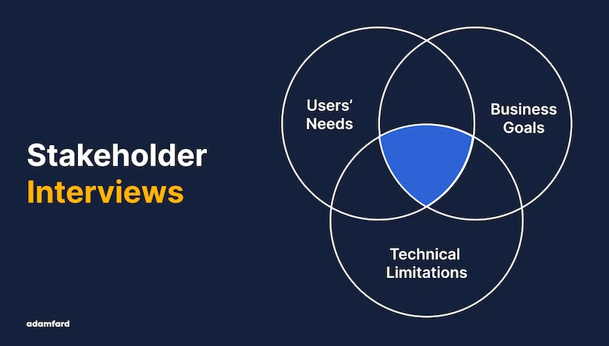

<https://adamfard.com/blog/stakeholder-interviews>

User interviews are a collaborative effort involving various professionals:

* **Researchers:** Often leading the charge, they plan, execute, and analyze the interviews.
* **Designers:** They can gain firsthand insights to drive their design decisions.
* **Product Managers:** They might participate to understand user needs and align the product roadmap.
* **Developers:** Occasionally involved, especially when technical feedback is anticipated.
* **Stakeholders:** Can sometimes observe (silently) to understand user perspectives and priorities.

## Lesson 1.3 Qualitative and Quantitative Data

### Understanding Qualitative and Quantitative Data

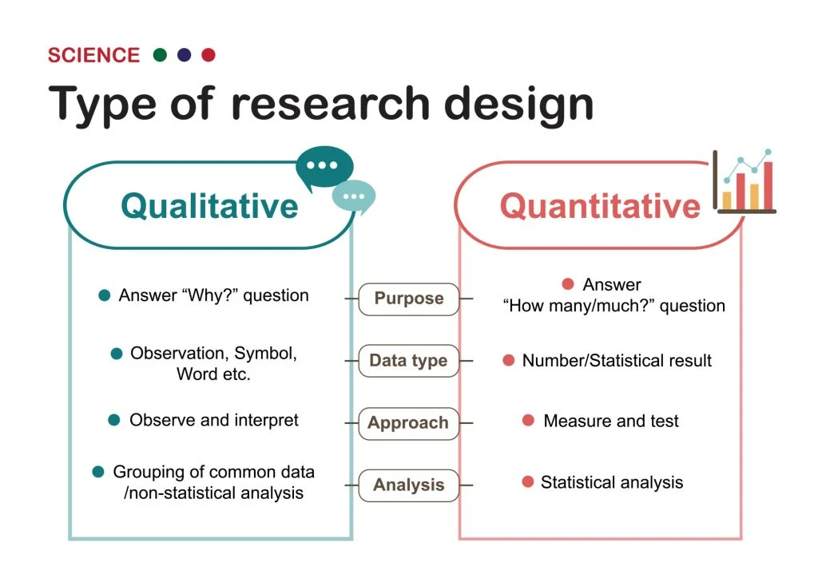

<https://www.simplypsychology.org/qualitative-quantitative.html>

Data, in user research, provides the foundation upon which design decisions are made. However, the type of data collected - qualitative or quantitative - can influence the depth and direction of those decisions.

* **What is Qualitative and Quantitative Data?**
  + **Qualitative Data:** Descriptive in nature and delves into the 'how' and 'why' of user behavior. It's often subjective, rich, and detailed.
  + **Quantitative Data:** Numerical and focuses on the 'what' and 'how many'. It offers statistical insights and can be measured and analyzed for patterns.
* **Importance to User Researchers:**
  + Helps in understanding user behavior, motivations, and frustrations.
  + Guides design decisions by providing evidence and reducing assumptions.
  + Balances subjective opinions with objective metrics.

### Deciphering Qualitative Data

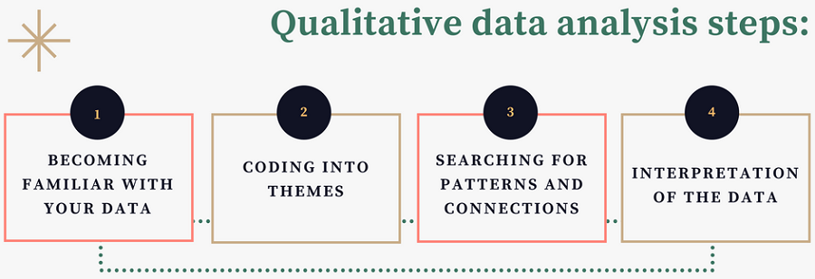

<https://www.intellspot.com/qualitative-data-analysis-methods/>

* **Qualitative Data Tells Researchers:**
  + The reasons behind certain user behaviors.
  + Contextual details about usability issues.
  + Deep insights into user emotions, preferences, and motivations.
  + Narratives that help in storytelling and emphasizing user-centric design.

### Gathering the Data

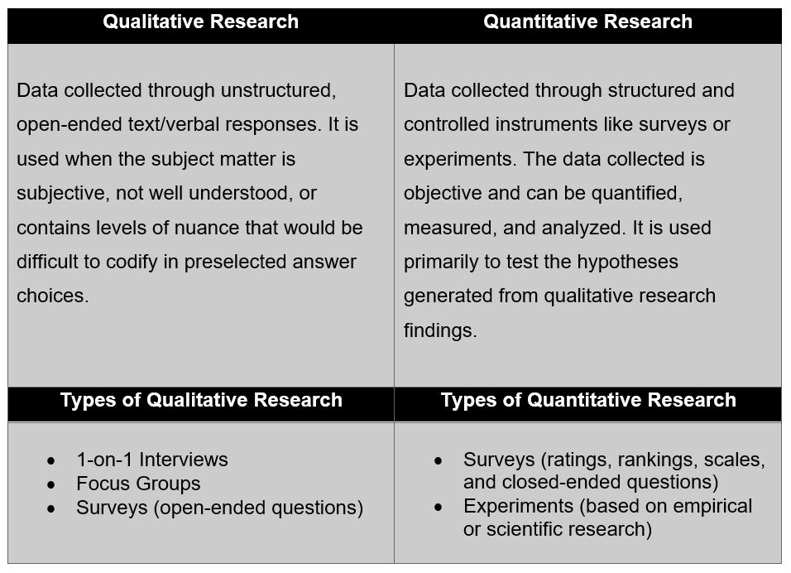

<https://glginsights.com/articles/qualitative-vs-quantitative-research-heres-what-you-need-to-know/>

* **For Qualitative Data:**
  + Interviews (face-to-face, phone, or video calls).
  + Observations (contextual inquiries).
  + Open-ended survey responses.
  + Diary studies or journals.
* **For Quantitative Data:**
  + Surveys with structured response options.
  + Web analytics.
  + A/B testing results.
  + Usage statistics.

### Recommended Tools for Quantitative Data Collection

* **Google Analytics:** A powerful web analytics service that tracks and reports website traffic. It provides detailed statistics and analytical tools for SEO and marketing purposes.

### Associated Tools with Quantitative Data

* **Hotjar:** Captures heat maps, session recordings, and provides surveys and feedback tools.
* **Optimizely:** Offers a platform for experimentation and A/B testing.
* **SurveyMonkey:** A tool for creating and analyzing surveys.
* **Mixpanel:** Advanced analytics for mobile and web, offering user tracking and cohort analysis.

### Comparing Qualitative and Quantitative UX Research

* **Depth vs. Breadth:**
  + Qualitative research provides depth, diving deep into user motivations and feelings.
  + Quantitative research offers breadth, giving a broad overview through numbers and metrics.
* **Subjectivity vs. Objectivity:**
  + Qualitative is often more subjective and requires interpretation.
  + Quantitative is objective, presenting clear, measurable data.
* **Flexibility vs. Structure:**
  + Qualitative research is usually more flexible and adaptable during the process.
  + Quantitative research requires a set structure and consistency.
* **Analysis:**
  + Qualitative data is analyzed through patterns, themes, and narratives.
  + Quantitative data is analyzed through statistical methods.

### Group Activity

Google Doc: <https://docs.google.com/document/d/1KZolZ-_zSbwRGTWrY5YM_0gdNiFzY5fEK6Ymd5oqCl0/edit?usp=sharing>

**Guiding Questions for the Group Activity:**

1. **Understanding the Context:**
   * What was the primary purpose of Aloha Airlines' website? (Booking flights, obtaining flight information, promotions, etc.)
   * Who are the potential users of this website, and what might their goals be?
2. **Visual Design Assessment:**
   * Based on the archive link, how would you describe the color scheme of the website?
   * Are the colors, buttons, and images inviting and relevant for an airline website?
3. **User Interaction and Functionality:**
   * How easy is it to navigate through the site?
   * Are the call-to-action buttons (like "Book a Flight") prominent and intuitive?
   * What elements on the page seem outdated or less user-friendly compared to modern websites?
4. **Content Evaluation:**
   * Is the content of the website clear and understandable?
   * Are there any elements on the site that you find redundant or unnecessary?
5. **Potential Pain Points:**
   * Are there areas on the website that could potentially confuse or frustrate a user?
   * How do the missing plugins impact the overall user experience?

## Lesson 1.4: Inclusive Design

### Defining Inclusive Design

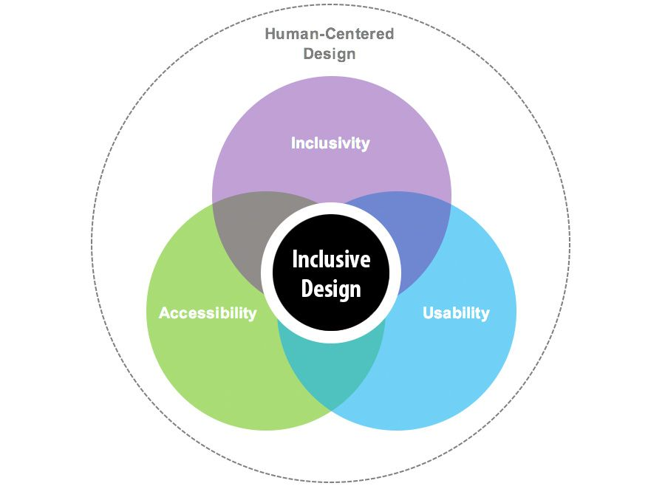

<https://www.consulting.us/news/6742/inclusive-design-is-integral-to-building-better-digital-experiences>

Inclusive design is a methodology that involves creating products, services, and environments that can be accessed, understood, and used to the greatest extent possible by all people, regardless of their age, size, ability, or disability.

### The Importance and Impact of Inclusive Design

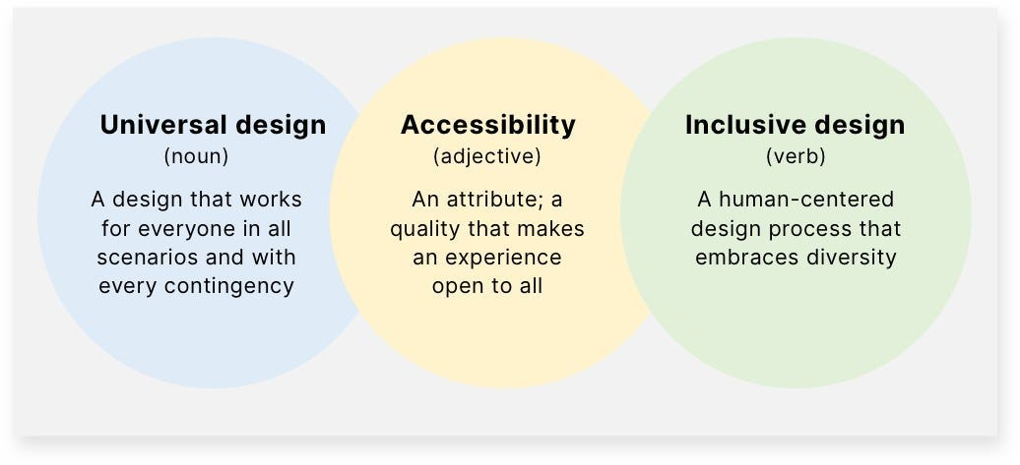

<https://bootcamp.uxdesign.cc/accessible-usable-and-inclusive-designs-d2a70208dca5>

* **Universal Usability:** By designing for everyone, we create products that are more versatile and can reach a broader audience.
* **Building Empathy:** It helps designers understand and cater to diverse user needs, fostering a sense of community and understanding.
* **Economic Benefits:** Making your product accessible to a larger audience increases its market potential.
* **Legal Considerations:** Many jurisdictions have regulations that require digital products to be accessible.

### Scenarios Demonstrating Inclusive Design:

1. A website that can be navigated using only keyboard commands.
2. A mobile app that offers voice commands for visually impaired users.
3. A product with instructions in multiple languages and easy-to-understand icons.

### Inclusive Design Addresses:

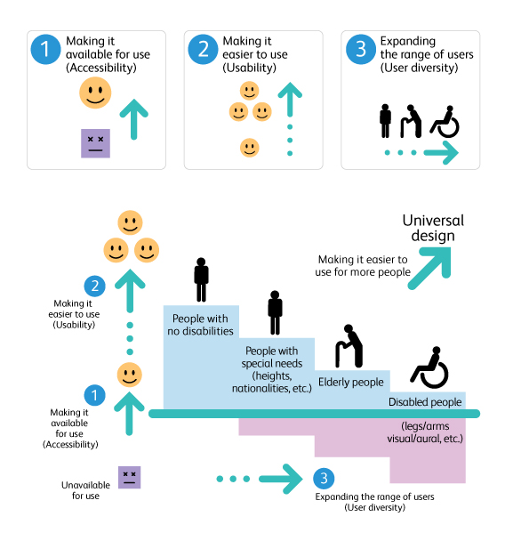

<https://www.ruthtrumpold.id.au/destech/?page_id=1486>

* **People with Disabilities:** Such as those with visual, hearing, cognitive, or motor impairments.
* **The Aging Population:** Catering to their changing needs and abilities.
* **Different Cultural Backgrounds:** Designing with a global audience in mind, considering diverse languages, customs, and traditions.
* **All Genders:** Ensuring that products and services don't favor one gender over others.

### Designing Inclusively

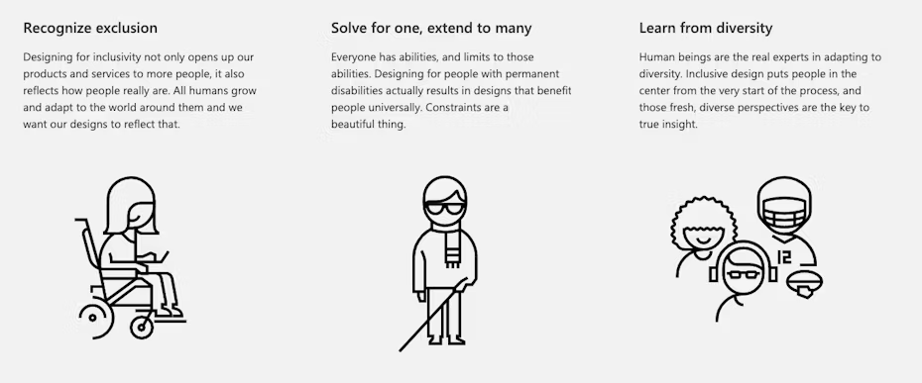

<https://99designs.com/blog/tips/inclusive-design/>

* **Pinpoint Target Audience:** Understand who you're designing for by identifying your core user base.
* **Create Personas:** Personas should cover a wide range of abilities, backgrounds, and needs.
* **Address Specifics of Target Audience Needs:** Dive deep into the requirements, preferences, and potential challenges of your audience.

### Understanding WCAG (Web Content Accessibility Guidelines)

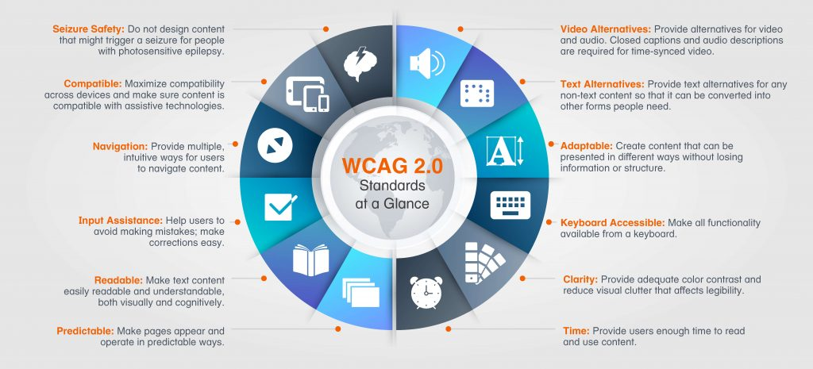

<https://www.w3.org/WAI/standards-guidelines/wcag/>

WCAG is a set of guidelines that ensures websites, applications, and other digital platforms are accessible to people with disabilities. There are three levels of conformance: A (lowest), AA, and AAA (highest).

### Examples of Inaccessible vs. Accessible Websites

* **Inaccessible Website:**
  + Use of low contrast colors.
  + Lack of alt text for images.
  + Non-responsive design that doesn’t work on mobile devices.
  + No captions for videos.
* **Accessible Website:**
  + High contrast color scheme.
  + Descriptive alt text for all visual elements.
  + Fully responsive design.
  + Video content with captions and transcriptions.

### Updating Inaccessible Websites

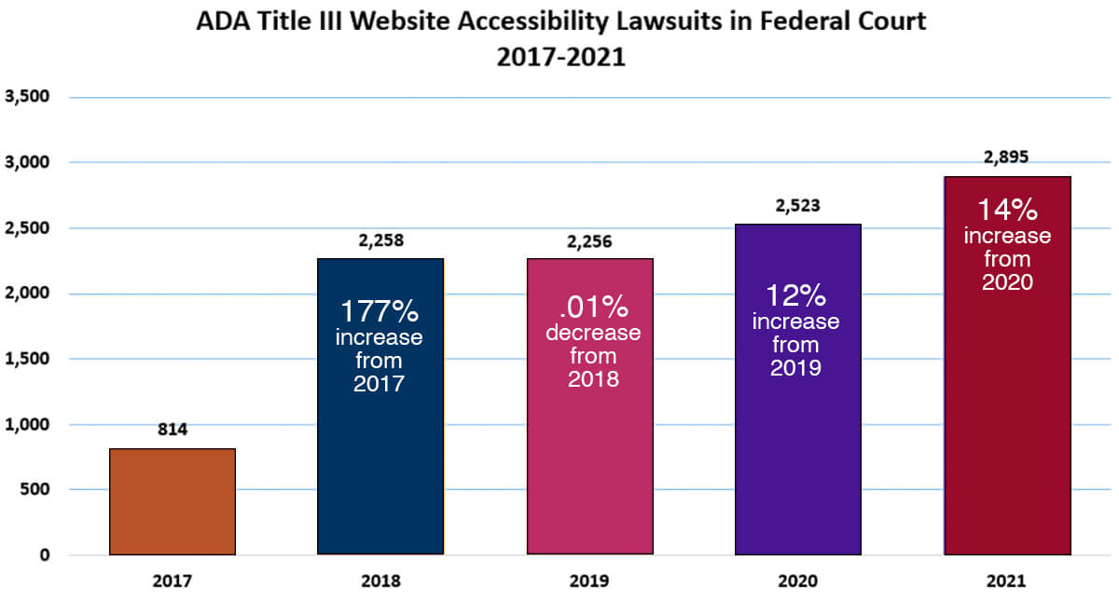

<https://getadaaccessible.com/the-legal-consequences-of-inaccessible-websites/>

* **Conduct Accessibility Audits:** Use tools like WAVE or AXE to identify issues.
* **Prioritize Fixes:** Address critical accessibility barriers first, such as navigation or form inputs.
* **Implement Keyboard Navigation:** Ensure the website can be navigated with a keyboard alone.
* **Offer Alternative Content:** For visually or audibly presented information, provide text alternatives.
* **Stay Updated:** Regularly review and update your site to adhere to the latest accessibility standards and best practices.

## Lesson 1.5: Human-Centered Design (HCD)

### Understanding Human-Centered Design

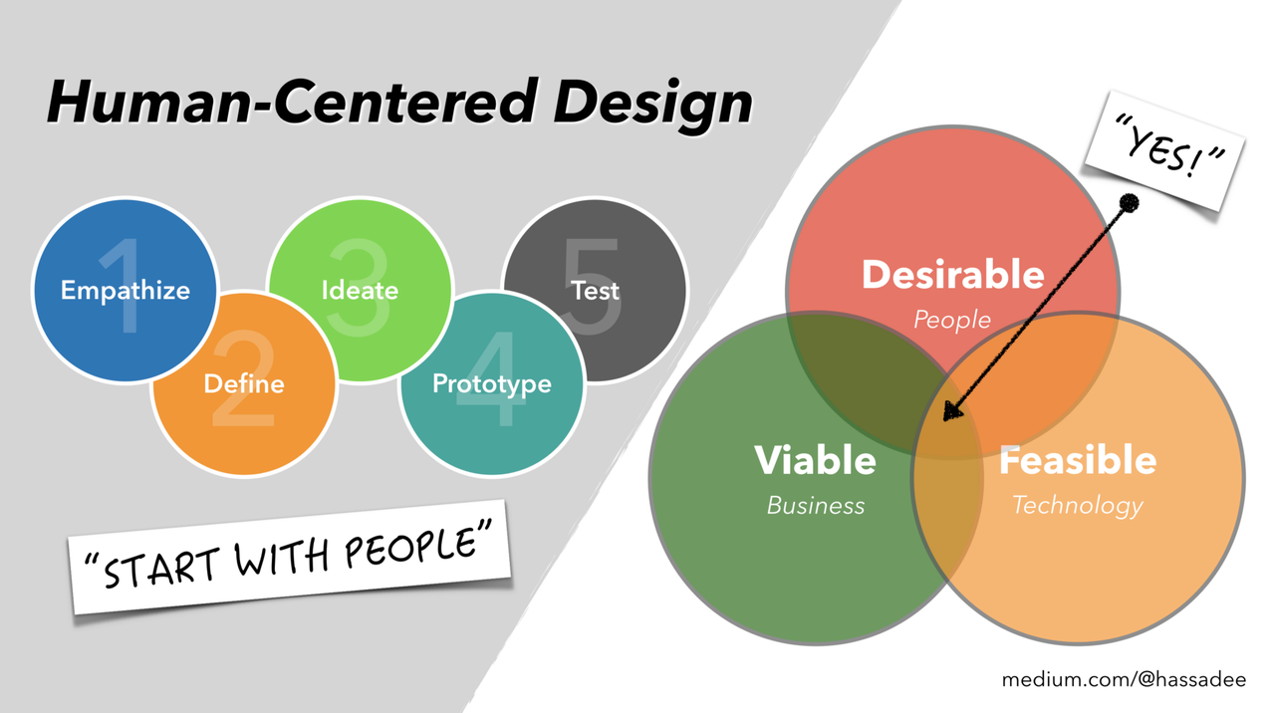Human-Centered Design (HCD) is an iterative design process in which designers focus on the users and their needs in each phase of the design process. HCD involves an open-minded approach to problem solving, with an emphasis on empathy for the people you're designing for.

### User Engagement in HCD

In HCD, user engagement is paramount. This entails:

* Directly involving users throughout the design process.
* Gathering feedback to refine and improve the solution.
* Ensuring that the end product genuinely meets user needs and solves real problems.

### The Human-Centered Design Process

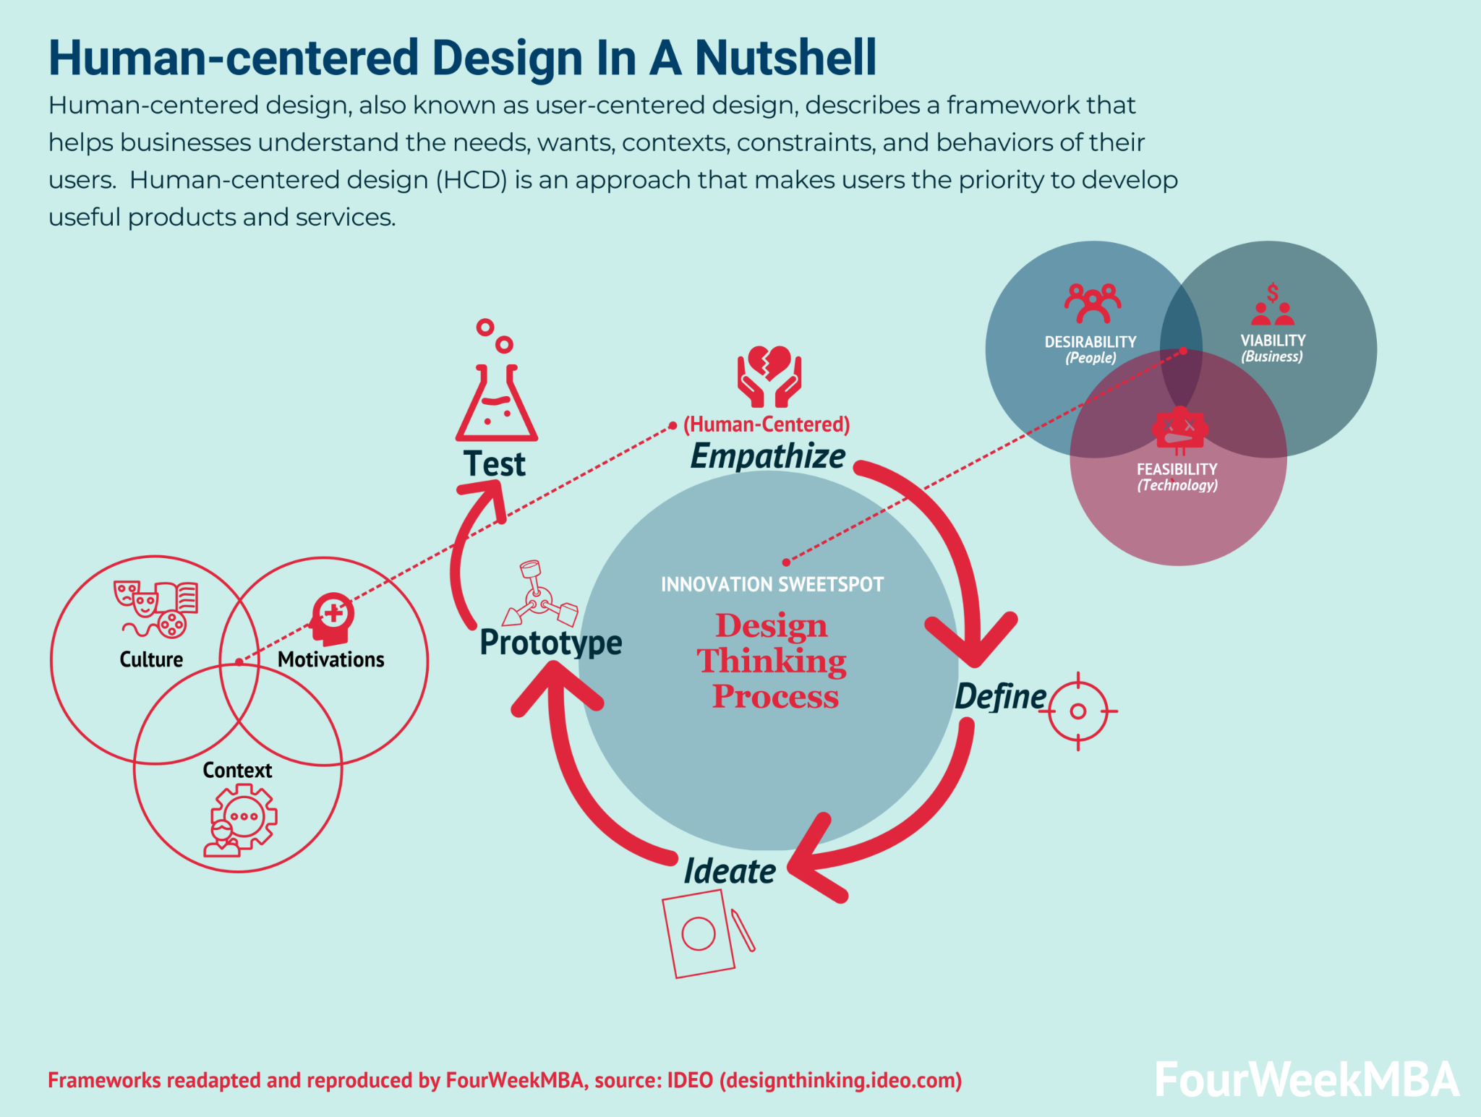

<https://fourweekmba.com/human-centered-design/>

The HCD process is often intertwined with design thinking and includes five main steps:

1. **Empathize:** Understand the needs, thoughts, emotions, and challenges of the target users. This is typically achieved through methods like interviews, observations, and immersion in the user's environment.
2. **Define:** Synthesize the information gathered during the empathize stage to create a clear and actionable problem statement. This step transforms empathy findings into actionable insights.
3. **Ideate:** Brainstorm possible solutions to the defined problem. Encourage wild and divergent thinking, fostering an environment where every idea is welcome.
4. **Prototype:** Convert the ideas into tangible, testable artifacts. These can range from low-fidelity sketches or paper models to more detailed digital or physical mock-ups.
5. **Test:** Test the prototypes with actual users. Gather feedback, learn what works and what doesn't, and refine the design based on these findings.

### Design Thinking: An Overarching Philosophy

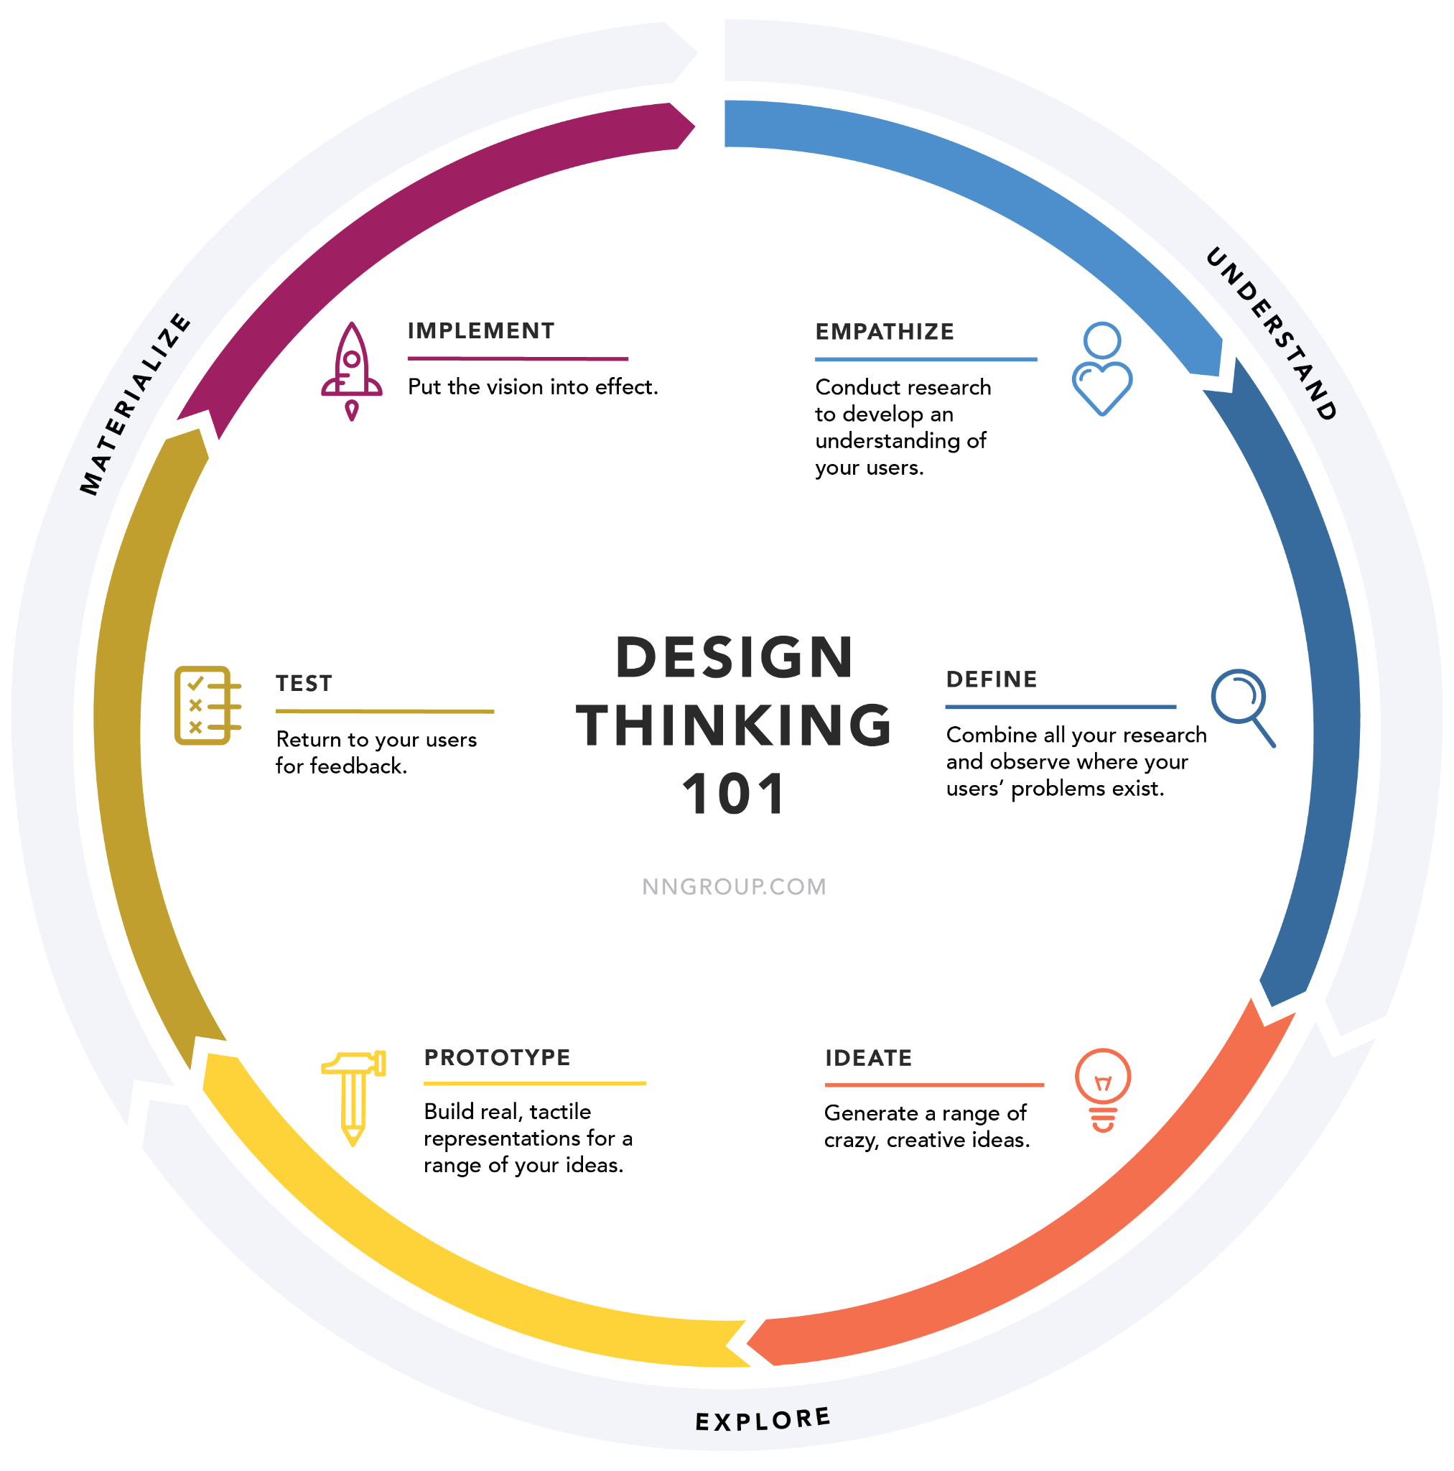

<https://www.nngroup.com/articles/design-thinking/>

Design Thinking is a user-centered approach to problem-solving that involves empathy, experimentation, and iteration. While HCD is a concrete process with steps, design thinking is more of a mindset or philosophy that places the user at the core of design efforts.

### Deep Dive into the HCD Steps:

* **Empathize:** It's not just about feeling sorry for users; it's about deeply understanding their context, challenges, and goals. Engage with them, walk in their shoes, and observe their interactions.
* **Define (Creating a Problem Statement):** Transform your observations into a concise problem statement. This should be user-centered rather than solution-centered. For instance, "Young parents need a way to monitor their child's health because they're often unsure about common symptoms" instead of "We need an app for monitoring child health."
* **Ideate:** Think broad and encourage wild ideas. Use brainstorming sessions, mind maps, and other ideation techniques. It's about quantity over quality at this stage.
* **Prototype:** Create tangible representations of your ideas. This allows both designers and users to interact with a solution, making abstract ideas concrete.
* **Test:** Engage users, let them interact with your prototype, and observe their behaviors. Ask open-ended questions and understand their experience. Use their feedback for refinements.

### Conclusion

Human-Centered Design is a holistic, user-focused approach that ensures the solutions developed genuinely address user needs and challenges. By placing the user at the heart of the design process, HCD helps in creating meaningful and impactful products and services.